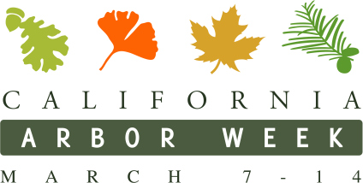
Organization Logo

FOR IMMEDIATE RELEASE | CONTACT: Name
Date you send advisory | Title
 | Cell Phone

[Organization] to Plant XX Trees at [location] for California Arbor Week
Who: Name of your organization, elected officials or local celebrities attending.
What: [Organization name] is hosting a local tree planting event to celebrate California Arbor week. XX trees will be planted by volunteers including [elected officials, local celebrities,] dedicated volunteers and students.
[Include additional visuals, interview opportunities or compelling factors of your event that would interest the media.]
Where: Exact address so reporters can easily locate
When: Date and time
Why: The purpose of California Arbor Week is to promote the important effects trees have on our lives and our communities. Through collaboration with volunteers, local officials, the support of California ReLeaf and the work of local organizations, California Arbor Week is sure to make a positive impact in the [Insert City] community.
Visual and Interview Opportunities Include:
- [List names and titles of those on site available for an interview and interesting visual opportunities that would create a good story for broadcast media in particular.}

Visit californiarealeaf.org/arborweek for more information.
###

