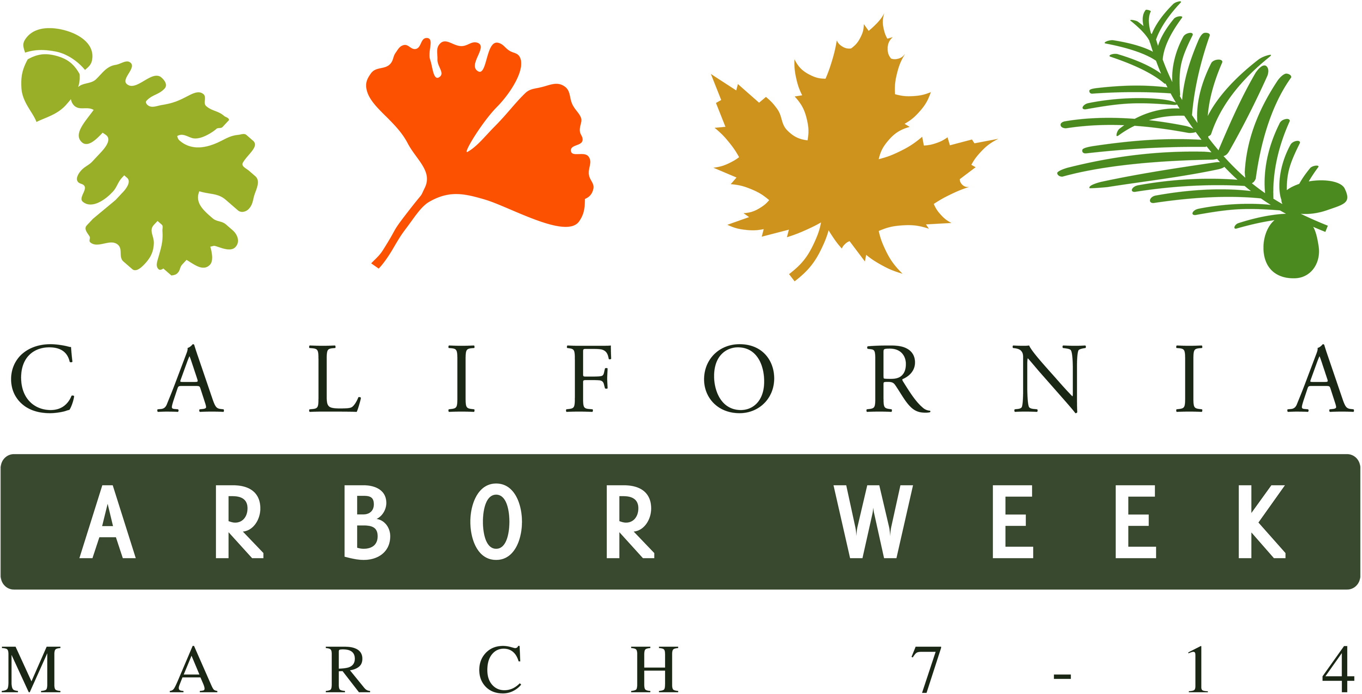
Insert your logo here

PRESS RELEASE

FOR IMMEDIATE RELEASE | CONTACT: Name
Date | Title
 | Phone

[Organization] Plants XX Trees in [City] for California Arbor Week
Events throughout California this week will yield xx new trees in local communities

[Insert City], Calif. – [Number of volunteers/attendees] [organization] volunteers came together today to plant xx donated trees at [specific location],one of many events taking place in celebration of California Arbor Week (March 7-14), a statewide initiative led by California ReLeaf. [Organization name] is a member of California ReLeaf’s network of nonprofit and community tree planting groups committed to increasing green spaces in their communities.

“We’re glad we could plant these trees today and as a result improve the air quality and tranquility of the area,” said [Name, Organization title]. “California Arbor Week is a great opportunity for individuals and organizations to not only plant trees but also raise awareness about the important benefits trees have in our lives and our communities.”

In addition to today’s event, [organization name] is [explain another event or program your organization is doing]. The public can get involved by [explain ways the public can participate through volunteering or donating money].

“We were fortunate to be able to provide $XX in funding to organizations this year for urban forestry projects resulting in XX trees planted throughout the state,” said Cindy Blain, California ReLeaf executive director. “We work with local organizations like [organization name] that understand the specific urban forestry needs in their communities and help us achieve our ultimate goal to preserve and enhance California’s urban and community forests.”

California Arbor Week runs March 7-14 every year to mark famed horticulturist Luther Burbank’s birthday. This year, legislation was proposed to define California Arbor Week in statute. Visit californiareleaf.org/arborweek for more info.

About California ReLeaf
California ReLeaf works statewide to promote alliances among community-based groups, individuals, industry, and government agencies, encouraging each to contribute to the livability of our cities and the protection of our environment by planting and caring for trees. The California ReLeaf Network is a state-wide forum for exchange, education, and mutual support for community-based organizations that share the common goals of planting and protecting trees, fostering an ethic of environmental stewardship, and promoting volunteer involvement.

About [Organization name]
[Insert boiler plate for organization]
###

