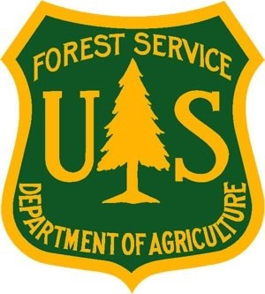
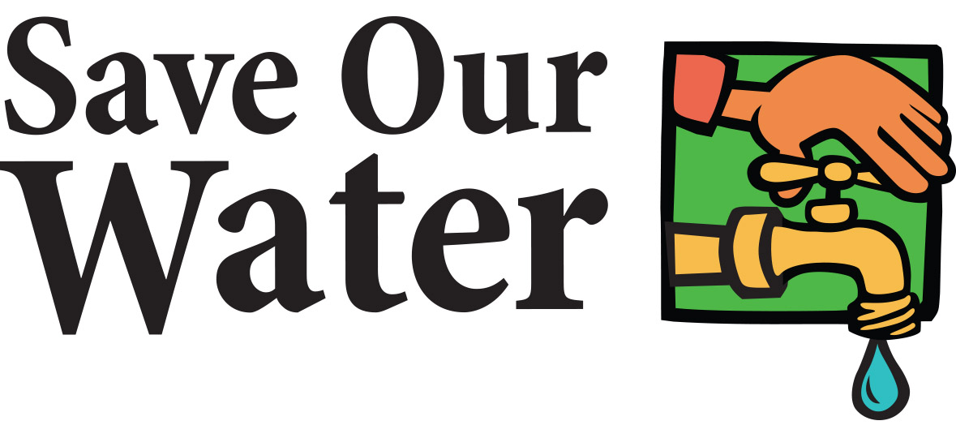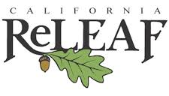
Media Contacts:

Jennifer Persike
Association of California Water Agencies
(916) 441‐4545 or (916) 296‐3981 (cell)
jenniferp@acwa.com

Keith Riggs
U.S. Forest Service
(707) 562-8852
keithriggsAD@gmail.com

Cindy Blain
California ReLeaf
(916) 497-0034 or (916) 248-6493 (cell)
cblain@californiareleaf.org

Tree Care Videos Released by California ReLeaf, Save Our Water and U.S. Forest Service
Videos help Californians with tips to care for trees during drought
Sacramento, CA: California ReLeaf, Save Our Water, and the U.S. Forest Service have partnered together to take the “Save Our Water AND Our Trees” message to the next level, creating two how-to videos to show California residents how to best care for their trees during this historic drought. CALFIRE and Davey Tree Expert Company provided technical support for the videos.
The new videos educate viewers to the benefits of trees to California and the importance of caring for trees in times of drought. The videos take viewers step-by-step through the watering process, ensuring trees get the water they need without waste. The videos offer tips on watering mature trees and watering young trees and are available on the U.S. Forest Service YouTube page and the Save Our Water and Our Trees site at www.saveourwater.com/trees.
As Governor Brown said in his March 2015 Arbor Day Proclamation: “In the spirit of preserving trees for future generations, Californians are advised to honor this occasion by planting drought-tolerant trees and learning best practices in caring for trees during a water shortage.”
“Trees in the urban environment are just as important as those in the forest,” said Sherry Hazelhurst, Director of State and Private Forestry for the U.S. Forest Service’s Pacific Southwest Region. “They are dynamic ecosystems that provide environmental services such as clean air and water. Trees cool cities and save energy; improve air quality; strengthen quality of place and local economies; reduce storm water runoff; improve social connections; complement smart growth; and create pedestrian-friendly communities.”
In July, a statewide consortium of urban forest and other concerned groups joined together to raise awareness for the importance of keeping California’s trees alive during drought, launching the current campaign. The videos are an easy way to learn how to care for trees now when Californians are letting their lawns go gold. Many were letting their lawns die, but had forgotten to water their trees.
“The importance of caring for trees during times of drought cannot be overstated,” said Jennifer Persike, Deputy Executive Director of External Affairs and Operations at the Association of California Water Agencies. “Save Our Water is proud to partner with California ReLeaf and the U.S. Forest Service to give Californians the right tools to conserve water and save trees this summer.”
Young trees and mature trees have different needs – young trees need a little water 2 - 4 times per week while mature trees need deep watering 1 - 2 times per month. The videos help residents learn more about the differences between young trees and big mature trees.
“This summer everyone needs to take special care to water their trees with the easy methods shown in the videos,” noted Cindy Blain, Executive Director of California ReLeaf. “These methods provide a short-term solution to keeping your trees alive for now, until Californians have time to redo their lawns and landscapes with drought-tolerant plants or warm-season turf and updated irrigation.” California ReLeaf is a statewide urban forest nonprofit providing support and services to over 90 community nonprofits that plant and care for trees.

###

